**1. Introduction:**

RADAR System is an object detection and tracking technology which uses radio waves to determine the direction, range, altitude and velocity of an object. Radar frameworks or systems are available in a variety of forms, sizes, and performance levels. There are a few options. There are a variety of ways to present radar operational data.  Radar systems that have been modified and have improved technology for handling systems are also available. At a higher level, these modified systems are used to gather or extract useful or crucial information [2].

The components listed below are relevant to our recommended system's functioning philosophy: an ultrasonic sensor tied to the digital input and output pins of a microcontroller (we chose Arduino). The Digital output and input pins are also linked/connected to the servo motor. The sensor and motor are linked at the same time, therefore our motor rotates near its axis when it rotates around from 0 to 180 degrees from extreme right to extreme left [3]. To show the data (distance and angle) on a computer screen, we utilise software called "Processing Development Environment" [1].

**2. Review of Literature:**

Following a review of some of the articles on the use of sensors and ARDUINO UNO, it was discovered that this concept is widely researched and it is a main concept that is continuing in development. Techniques used are not only effective, but also cost-effective [5]. Not only that, but additional extremely beneficial ultrasonic sensor uses were also noticed. This paper discusses a monitoring system that uses an ultrasonic sensor and a microcontroller to measure the speed of waves and the high of a river (Arduino). If river cannot handle the quantity of water, the liquid will overflow and flood the land, causing a phenomena known as a flood or surge. We can avoid flooding by identifying high of the water and monitoring its speed earlier. If we discover an issue early enough, we can remedy it before it becomes a catastrophe. A basic water level was used to test the system, and it was revealed that ultrasonic had a 96.6 percent accuracy. When the Arduino was employed as the application's controller, the test was completed. For further study, data on the depth level and water speed of this system will be uploaded to an online database server, which will be analysed on a regular basis [8]. The goal of the study is to offer a system for intelligent driver monitoring and vehicle control. The author discusses after analysing some of the most ordinary or customarily common causes of accidents nowadays. These include drunkenness, carelessness, exhaustion, or medical illness on the part of the driver. The framework's different components are checked and determined to be in excellent working condition, including motors, relays, the power unit, and the ESP8299 module. When another vehicle approaches his automobile, an ultrasonic sensor alerts the driver.The status of the driver can be determined with the help of sensors installed in the vehicle, and the proprietor can be updated on the subtle elements. This technology solves all of the factors that have caused earlier technologies created for this purpose to fail, making it more helpful, efficient, cost-effective, and time-consuming [7].

The authors of this research study describe how to detect radio waves and track or range them using a radar set made up of components such as an ultrasonic sensor, a servo motor, and an Arduino. The author explains how the creation of an ultrasonic distance measurer solved the lineear measurement problem, which made it difficult to quantify distance between specific objects. It enables noncontact measurements to be taken. This system is a highly helpful radar system, according to the author, since it can read or track the distanceance and angle of an obstruction and show it on a monitor screen. The ultrasonic sensor was put on top of the servomotor to detect impediments in the right and left directions from 0 to 180 degrees. This research demonstrates one of the most common of influential method for spotting barriers in a familiar area. This system is powered by a mobile camera that runs on Android. Visually impaired people have a comparatively harder time detecting obstacles and navigating through them while walking. They employ sticks to solve this problem, however this method, or the Arduino-based radar system strategy, is not the best way to go about it. Object indication or detectors can help individuals avoid accidents or collisions, or they can help with correct map reading. Indoor mapping is the major goal of the algorithm highly suggested in this thorough study. All distanceinctive floors are considered in the indoor environment, and a single picture is retained or saved for each distanceinctive level. These floor images will serve as a reference. This algorithm, according to its designer, is 96 percent accurate and functions in real time. To overcome the challenges, we not only use a SONAR sensor but also a laser camera in order to overcome our problems and optimise the project. This study [9] proposed a method for detecting hindrance in a known condition utilising an android-based flexible camera that scans a pre-selected region for impediment location before capturing the image.

**3. Report on Present Investigation:**

The life cycle of the Radar System is depicted in the diagram below, which includes individual component design, testing, installation, and overall system testing are all tasks that must be completed. The phases indicated below can be used to break down these steps:

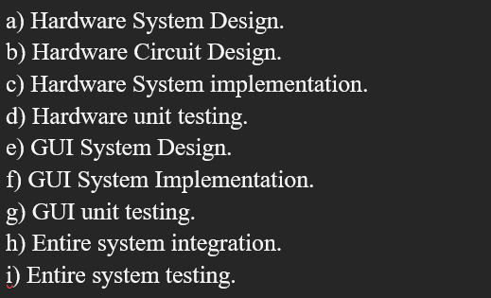

**Hardware Description:**

Ultrasonic Sensor:

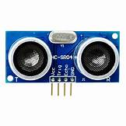

Fig 1. Ultrasonic Sensor

Ultrasonic and sonar sensors function the same way, it uses sound waves in order to measure the distance between objects. The sender sends sound waves in a given frequency and direction, and the receiver waits for them to return. By calculating the time, it takes for a sound wave to return, we may determine how far away something is.

Servo Motor:

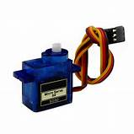

Fig 2. Servo Motor

A servomotor is a whirling motor with precision control over position and speed. It is built using a motor and a location feedback sensor. It also necessitates the use of a complex controller, which is usually a separate module dedicated to servomotors. Servomotors are not a distinct type of motor, but rather use mechanism to achieve closed loop control with a standard open loop motor, according to its essential operating concept. Robotics, CNC machines, and automated manufacturing are just a few examples of where servomotors are used.

Arduino :

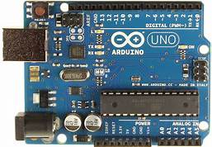

Fig 3. Arduino Uno

The Arduino platform is a free of charge and open source hardware and software electronics platform. Thus, making it simpler and easier to not only write code but also upload it to the Arduino board. Windows, Mac OS X, and Linux are all supported. The environment is written in Java and uses open-source tools such as Processing as a foundation. This application can be optimised and run on any Arduino board. The Arduino software IDE also includes a text editor for writing code, a message box, a text terminal, and a toolbar along with basic function buttons. By uploading and downloading code, it links to Arduino and Genuine devices. Sketches are programmes developed to be executed in the Arduino programming language.

Bread board:

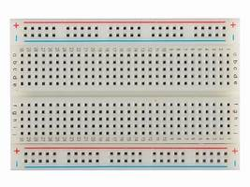

Fig 4. Bread Board

When learning how to create circuits, breadboards are one of the most important components. This lesson will teach you all you need to know about breadboards, including what they are, why they're called that, and how to use one. You should now be able to design a basic circuit on a breadboard and understand how they function.

Jumper wires:

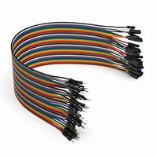

Fig 5. Jumper wires

Jumper wires are cables with connector pins on both ends that are used to connect two sites without soldering. With breadboards and other prototype tools, jumper wires are widely utilised to allow for fast circuit adjustments as needed.

1. Hardware System Design

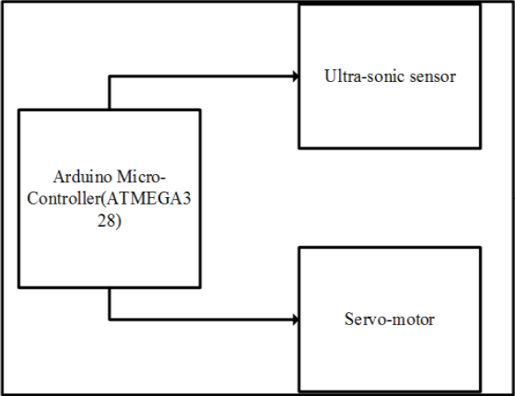

Fig 7. Hardware System Design of Radar System.

The hardware system comprises of three parts: an Arduino, a servo motor, and an ultrasonic sensor. A servo motor is mounded with an ultrasonic sensor, which aids in movement and provides a turning mechanism. The Arduino uno not only controls the Arduino Uno but it also powers it as illustrated in Figure

(B) System circuit design

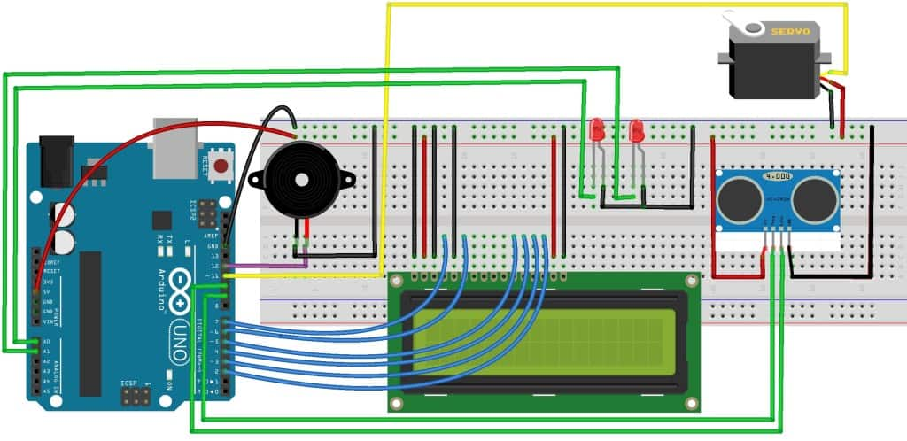

Fig 8. System circuit design

A hardware system design produced in the Fritzing environment is shown in Figure. It shows how several electrical components are linked together. The pins of the sensor are linked to the Arduino's D10 pin, the servo motor's control line to the Arduino's D8, and the echo pin to the micro-controller's D11. The VCC pins of the motor and ultrasonic sensor are joined to the Arduino's 5V pin, while the Arduino's ground pin is joined to both the motor and ultrasonic's ground pin.

(C) System Circuit Implementation on Bread Board –

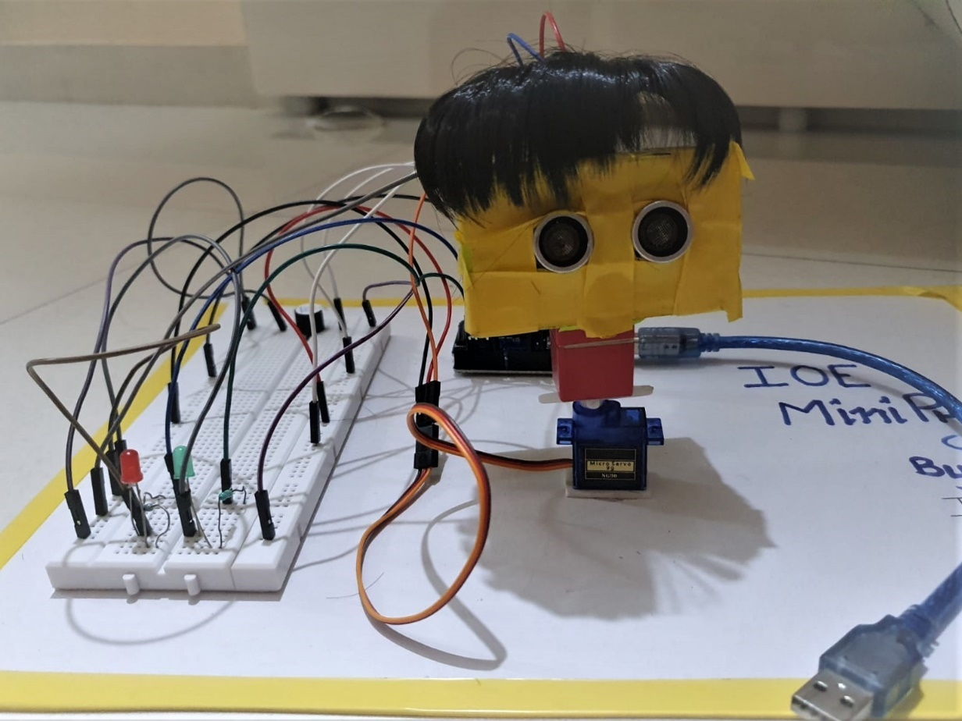

Fig 9. Implementation on Bread Board

The following diagram depicts the hardware system in its entirety. The ultrasonic servomotor may be seen mounted on a servo motor and positioned above the breadboard. On the alternate side of the breadboard, Arduino is installed, the whole link is formed between them. To keep the micro controller and motor from tripping over as the servo motor travels, they are stuck to the breadboard. To create code and upload it to Arduino, the Arduino IDE was utilised. The Arduino code reads the servo motor's location and calculates the distance to the closest item in the route.

The Arduino code is given below:

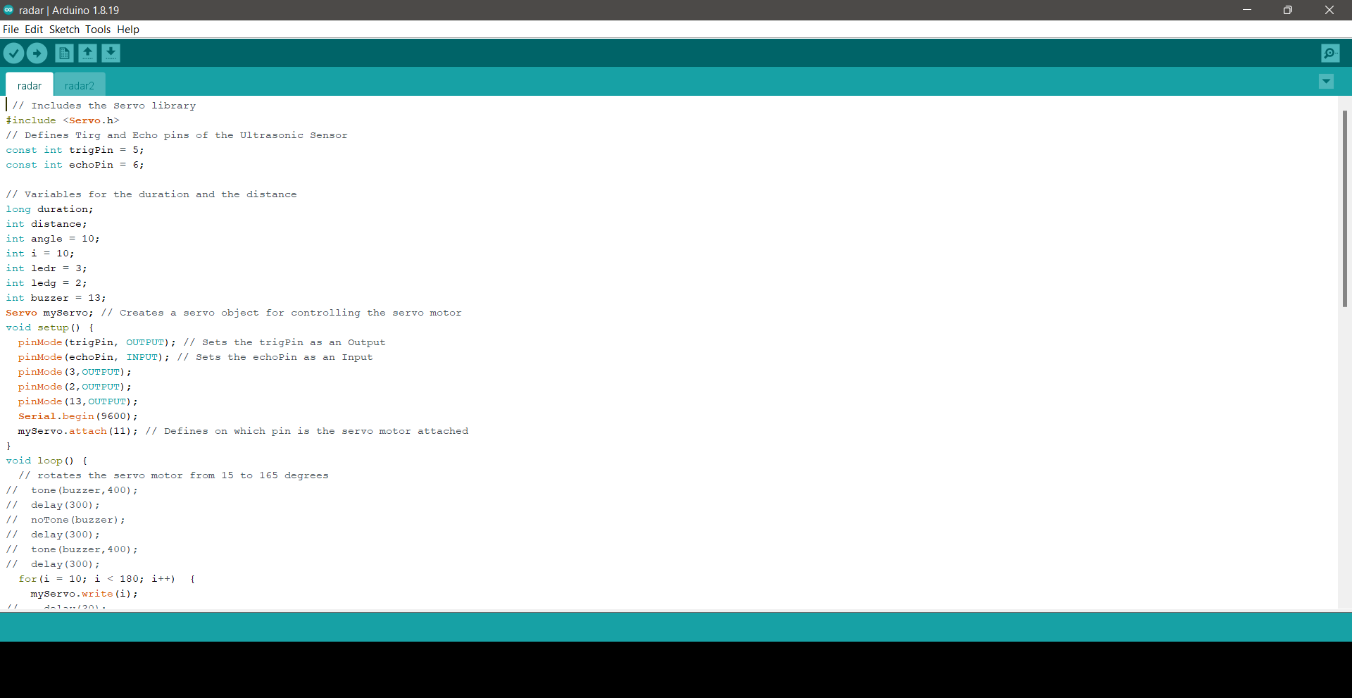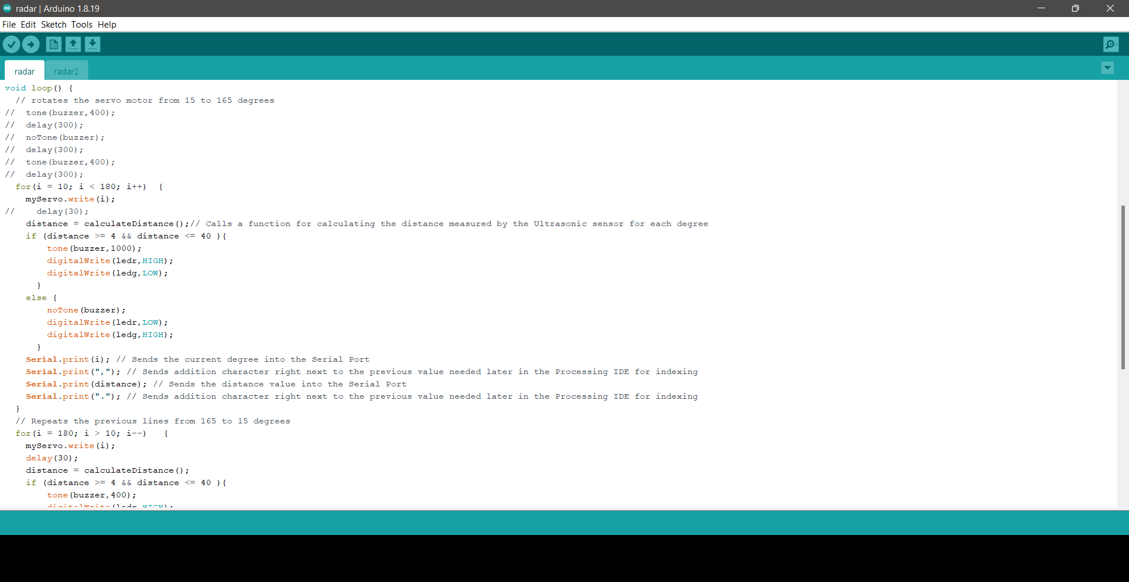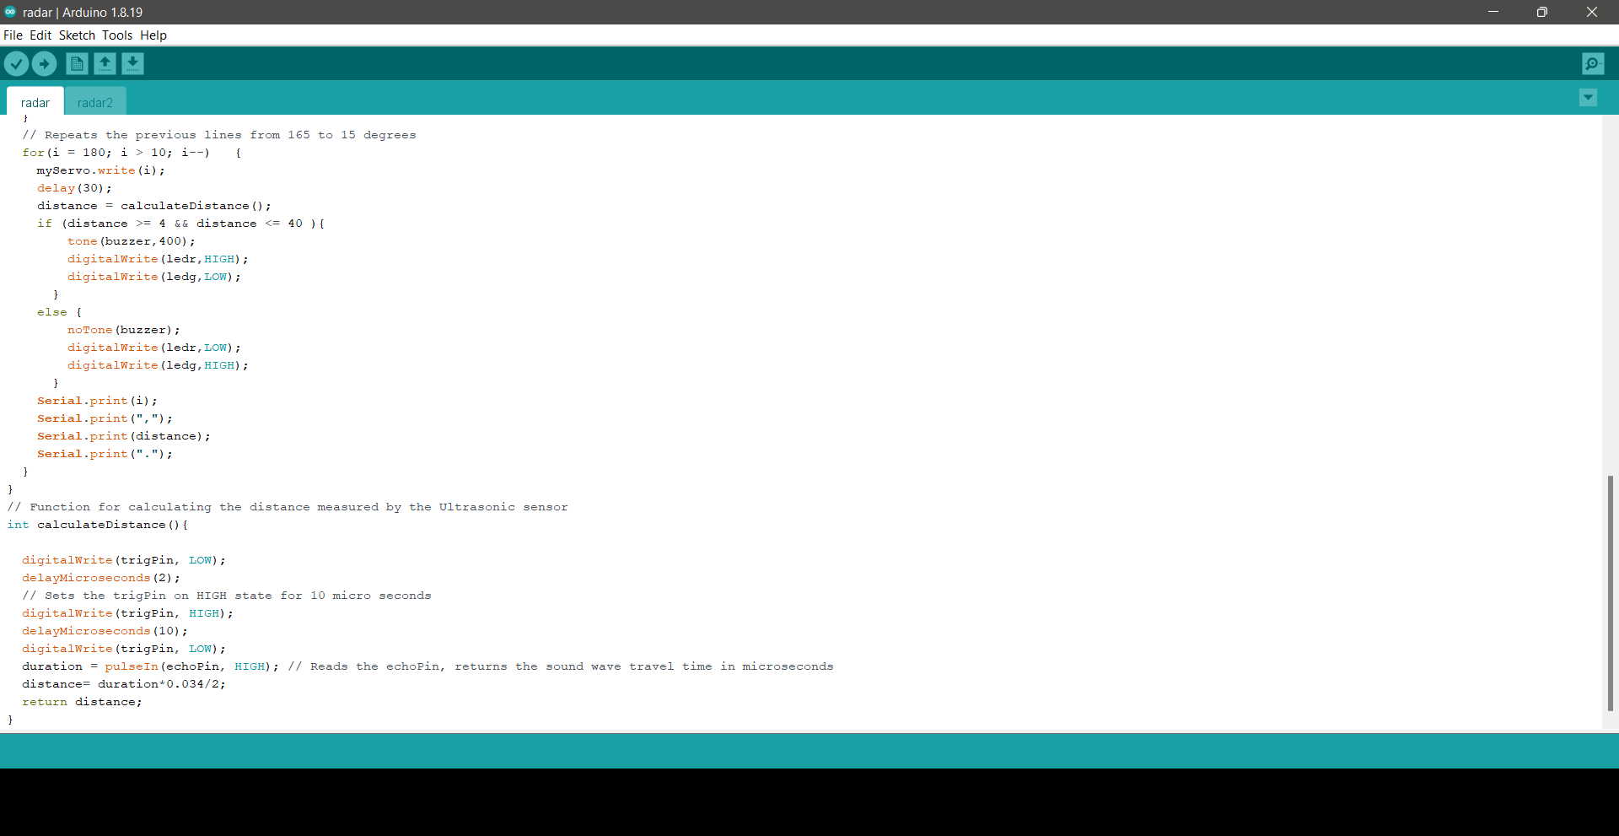

Code to display output on laptop:

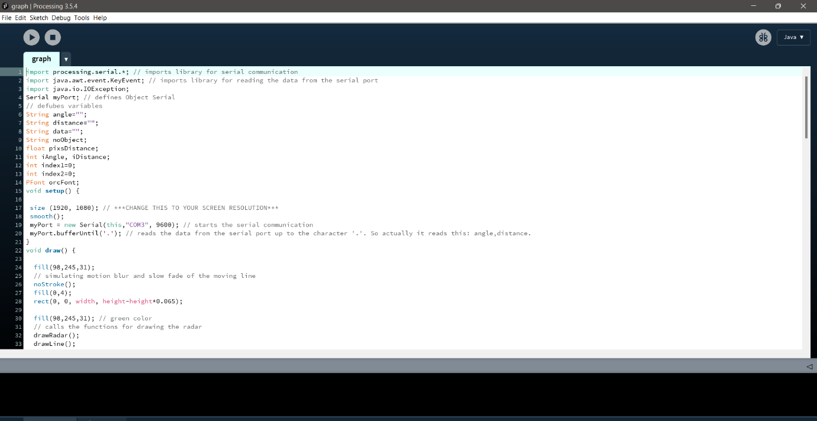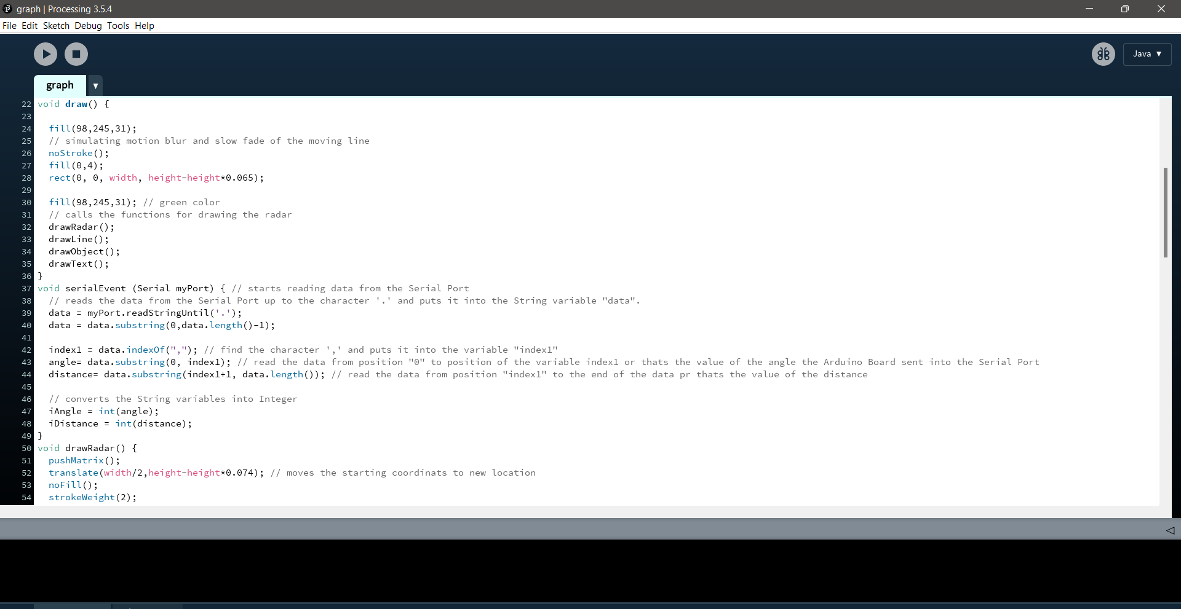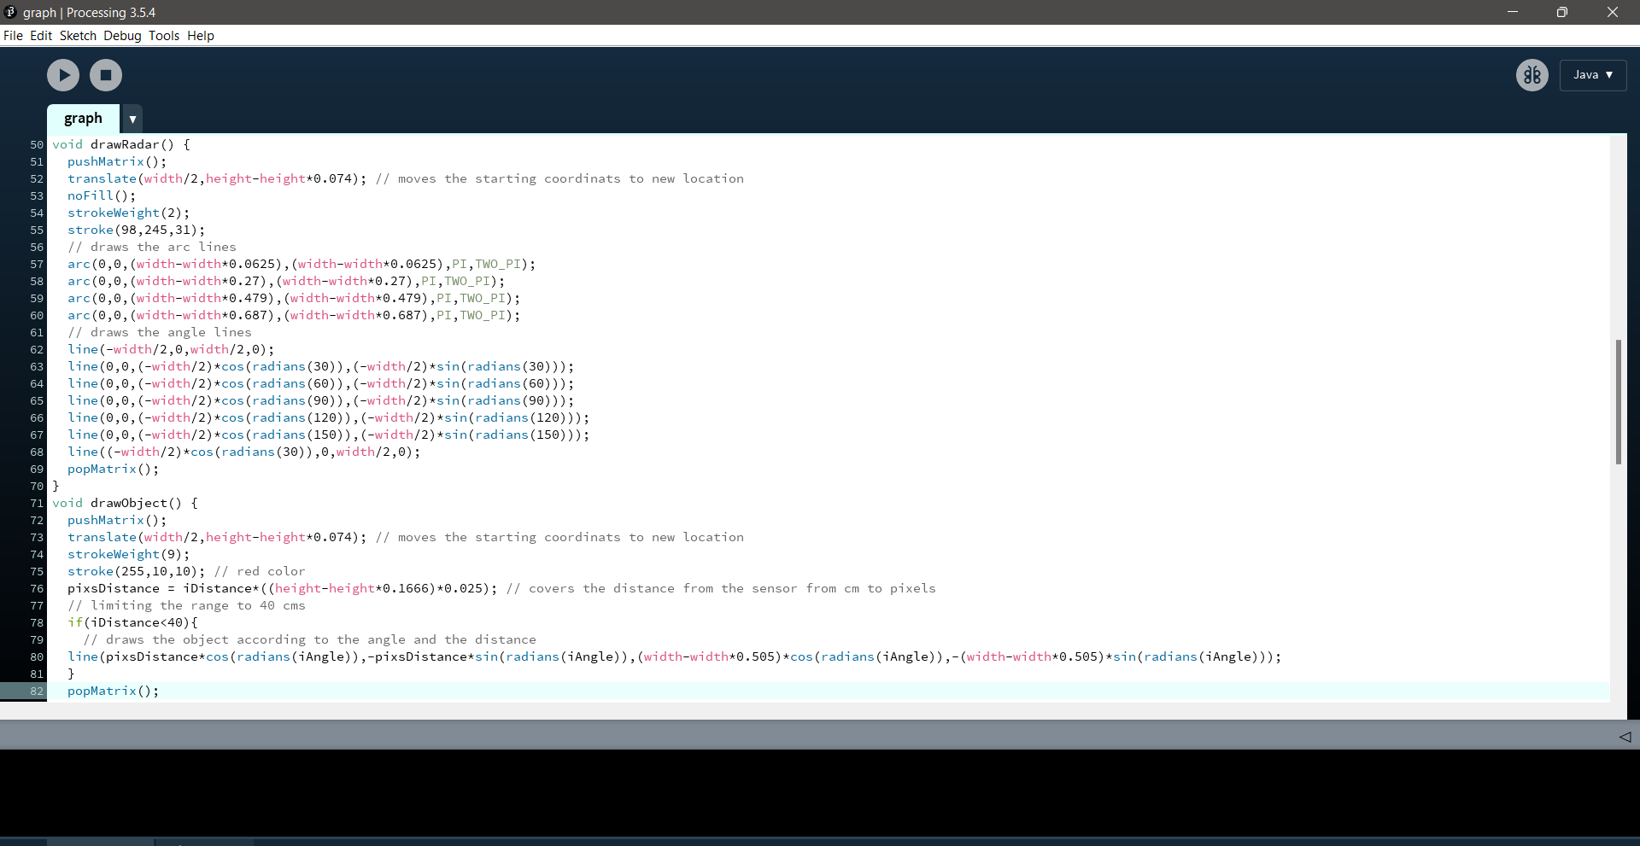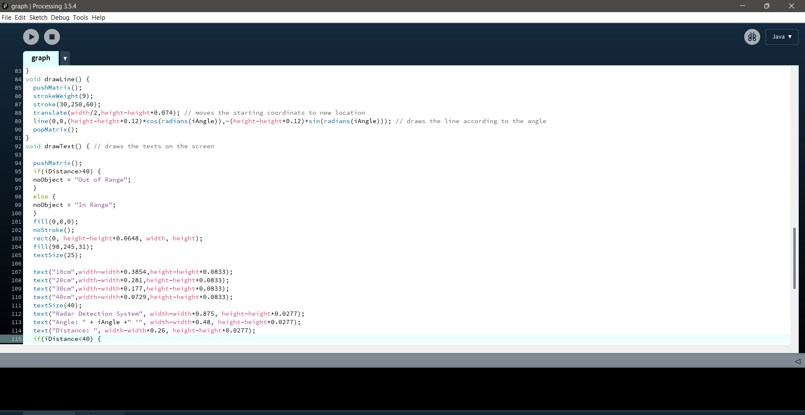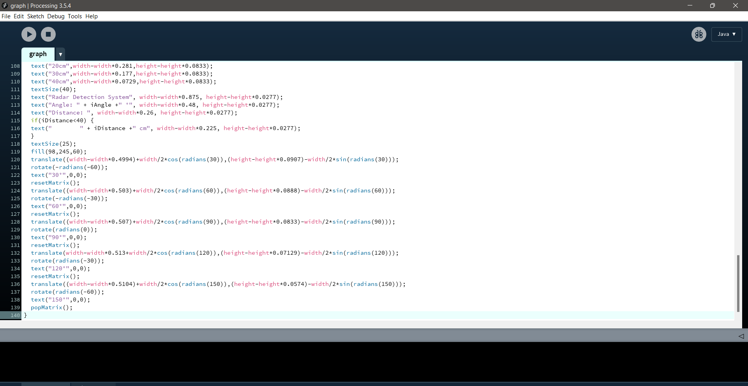

(D)Hardware system testing – The Arduino was connected to the development machine through a wire. Using the Arduino IDE, we were able to get a result in the serial monitor.

(E) Design and implementation of a graphical user interface system The GUI was created using the JAVA programming language and consists of two classes. The radar project's object class represents the objects it meets, such as distance, target/range, and angle/direction of position. The distance () method, angle () method, and location () method all accept needed values like distance and angle and display them on a GUI for simulation. Figures depict a line sweep from one direction to the other, as well as a smudge in the GUI where ultrasonic sensors detect impediments.

WORKING:

The project’s system’s aim is to calculate the distance, location, and speed of obstacle placed at a specific distance from the sensor. The sensor enables the servo motor to rotate in order to deliver the ultrasonic wave in various directions. This wave travels through air and is reflected back after colliding with any item. This wave is calculated by ultrasonic sensor and its characteristics are examined, with the results shown on the screen as metrics such as object distance and location. The Arduino IDE is used to write and transfer code in Arduino, allowing us to detect the position or angle of a servo motor, which is conveyed over the serial port together with the distance covered by the nearest item in its path. The outcome of all of this labour is displayed in the processing programme, which displays the object's input/output and range [4].

It displays a green light all of the time, indicating that object detection is active, and a buzzer and red light begin as soon as an item approaches it (0 degrees to 180 degrees) across a distance of 4cm to 40cm.

**4. Result and Discussions:**

As we have previously stated in the study report, the project consists of the these components: a servo-motor, an ultrasonic sensor and an Arduino. The aim of the project is to find out the barrier's distance and angle and to show the information. We may get an estimate of the radar's effectiveness by testing items at various highs and seeing how quickly or smoothly it identifies an object and gives us a predicted range of the obstacle [3]. The outcomes of our design's monitor screen when the sensor rotates across the region and finds an impediment are shown in the following image. The existence of an obstruction is shown by the red region, and the angle of incident and distance are presented below.

Testing of the system

1. Object A is kept at 20.5 far from the radar, radar gives the distance 32 cm, so: o error =(32-20.5)/20.5)*100= 3.918% o efficiency 1 = 100-error =94.08%

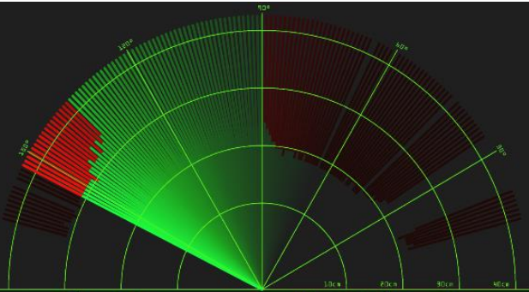

1. object 2 placed at a distance of 19.3 cm, radar gives the distance 21 cm so: o error = ((21-19.3)/20.3)*100 = 2.44% o efficiency 2 =100-error= 95.55%

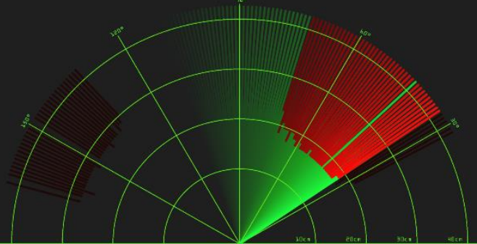

After observing and calculating, we can conclude that the project is 93.815% efficient.

**5. Conclusion and future scope of project:**

In this work, an Arduino, a servomotor and an ultrasonic sensor were used to create a radar system that can find out the location and distance of any barrier in its path and transform it into a graphically representable form. This method may be used for object identification. The project’s range is calculated by the kind of ultrasonic sensor that is used. The sensor we used in the project was the HC-SR04, which has a range of 2 to 40 cm. Project creators have more access over different types of applications. The whole-system mapping approach is evaluated in our study on modest principles or scale [9]. The area which is selected for our design is large. This system have been put into N number of applications [3]. The system can only detect objects from 0 to 180 degrees. Because of this limitation, the method cannot be utilised to find out larger-scale barriers. The system's efficiency can be improved by using a 360-degree rotating servo motor.